**6-AMALIY TOPSHIRIQ.**

**1-topshiriq: quyidagi jadvalni to’ldiring?**

|  |  |  |  |  |
| --- | --- | --- | --- | --- |
|  | **Modda** | **Jami bog’lar soni** | **δ-bog’** | **π- bog’** |
| **1** | **Al2(SO3)3** |  |  |  |
| **2.** | **Na2HPO4** |  |  |  |
| **3.** | **Zn(NO3)2** |  |  |  |
| **4** | **Mn(OH)4** |  |  |  |
| **5.** | **Ca(ClO3)2** |  |  |  |

**2-TOPSHIRIQ.**

|  |  |  |
| --- | --- | --- |
| № |  |  |
| 1. | Kovalent bog’lanish hosil qilish usullari |  |
| 2. | Kovalent bog’ning yo’nalganligi |  |
| 3. | Kovalent bog’ turlar |  |
| 4. | Donor akseptor bog’lanishli moddalarga 5  ta misol yozing. |  |
| 5. | Bog’ uzunligi qanday aniqlanadi |  |
| 6. | Bog’ barqarorligi qanday aniqlanadi |  |
| 7. | Bog’ qutbliligichi? |  |



**3 - topshiriq: Quyidagi jadvalga kimyoviy bog’larga xos xususiyatlarni yozing.**

|  |  |  |  |  |
| --- | --- | --- | --- | --- |
|  |  |  |  |  |
| KOVALENT BOG’LANISHGA XOS XOSSALAR |  |  |  |  |
| ION  BOG’LANISHGA XOS XOSSALAR |  |  |  |  |

**4- topshiriq: USHBU MUAMMOLI VAZIYATNI IZOHLASHGA HARAKAT QILING?**

|  |  |  |  |  |  |  |  |  |
| --- | --- | --- | --- | --- | --- | --- | --- | --- |
|  | | |  | | |  | | |
|  | Muammoli vaziyat |  |  | Muammoli vaziyatning kelib |  |  | Vaziyatdan chiqib  ketish harakatlari |  |
|  | chiqish sabablari |  |
|  | | |  |  |

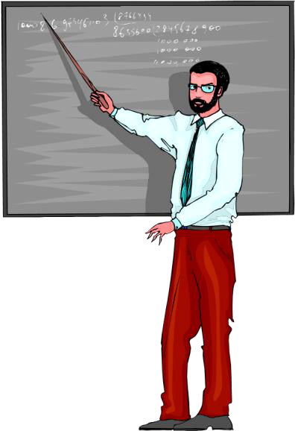

|  |  |  |  |  |  |  |
| --- | --- | --- | --- | --- | --- | --- |
|  | | |  | |  | |
|  | Gibridlanish nazariyasi |  | Atomlar orasidagi bog’lanish |  |  |  |
|  |
| odatda har xil energetik |  | |
|  | holatlarda bo’lgan elektronlar |
| orasida yuzaga keladi. Atom |
| orbitallarning o’rniga hosil |
| bo’lgan gibrid orbitallar |
| molekula hosil qilishini |
| sababini tushuntiring. |
|  |
|  |
|  | | |  |